Ex No.06 | Usage of Files operations | Reg. No: URK24CS9068
14.03.25 | in Python

Q7. Write a Python program to create a file where all letters of the English alphabet are listed by the specified number of letters on each line based on the input ‘n’.
Aim: To write a Python program that creates a file and writes the English alphabet into it with a specified number of letters per line.
Objective: To practice file handling and string slicing techniques by distributing characters into formatted lines.
Algorithm:
Step 1: Start
Step 2: Import the string module to access the English alphabet
Step 3: Accept input n for number of letters per line
Step 4: Slice the alphabet string in chunks of n characters
Step 5: Open a file in write mode
Step 6: Write each chunk on a new line
Step 7: Close the file
Step 8: End
Program:
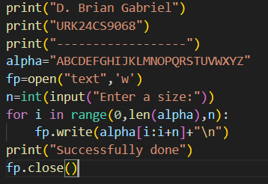
Text File:
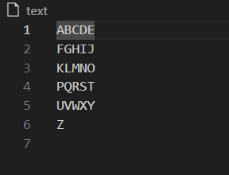
Output:
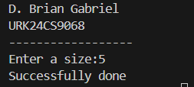
Result: The program successfully writes the English alphabet into a file with the specified number of letters per line.

Q8. Write a Python program to read the first n lines of a file.
Aim: To write a Python program that reads the first n lines from a text file.
Objective: To understand file reading and line-by-line access using Python.
Algorithm:
Step 1: Start
Step 2: Accept input n (number of lines to read)
Step 3: Open the file in read mode
Step 4: Loop through the file using readline() or a loop with enumerate()
Step 5: Print only the first n lines
Step 6: Close the file
Step 7: End
Progam:
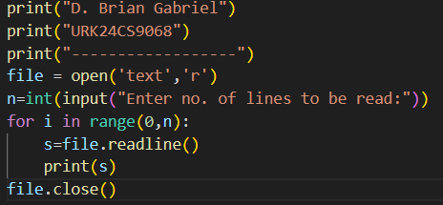
Text File:

Output:
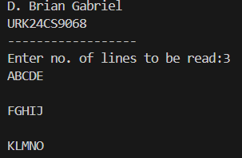
Result: The program successfully reads and prints the first n lines of the file as specified by the user.

Q9. Write a Python program to count the frequency of words in a file.
Aim: To write a Python program that reads a file and counts the frequency of each word.
Objective: To practice file handling and dictionary operations by computing word frequencies from text
Algorithm:
Step 1: Start
Step 2: Open the file in read mode
Step 3: Read the entire content and split it into words
Step 4: Use a dictionary to count word occurrences
Step 5: Print the word and its frequency
Step 6: Close the file
Step 7: End
Program:
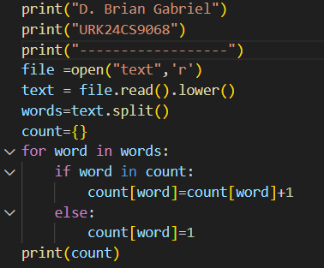
Text File:
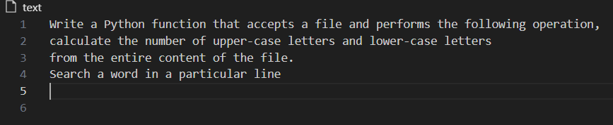

Output:

Result: The program successfully reads the file and displays the frequency of each word.

